VLC or VideoLAN Client is an open source and free cross platform media player that can play a wide variety of multimedia files such as video and audio files. VLC was an academic project for streaming video by a non-profit organisation named VideoLAN in the mid-1990s in Paris, France. VLC runs on all popular operating systems and different mobile devices.

In this project we will be focusing on VLC for android which is a port of VLC Media Player for android devices. The VLC app can play almost all types of video formats such as mp4, avi, mkv, mov and audio formats such as ogg, flac, wv and aac files and also Network Streams such as adaptive streaming. VLC also supports disk share through Network Drives and Network Shares similar to the original desktop version on PC. VLC also support Closed Captions, Teletext and Subtitles in their software.

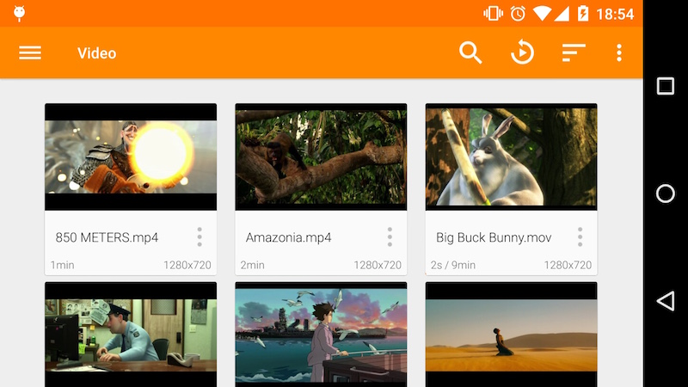

Figure 1. VLC Video Library (Insert citation reference here)

The VLC app has a media Library for both audio and video files, which allows browsing to the phone’s folders directly. It has a complete audio media library that supports headset controls and cover art for each of the songs in the library.

VLC has a wide variety of features which is why we are only focusing on the media library part of the app for this project.

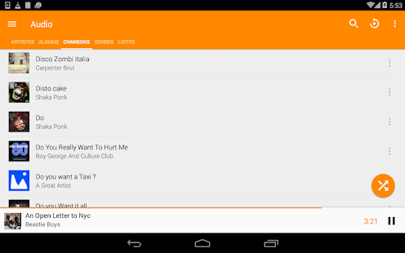

Figure 2. VLC Audio Library (Inset citation reference here)

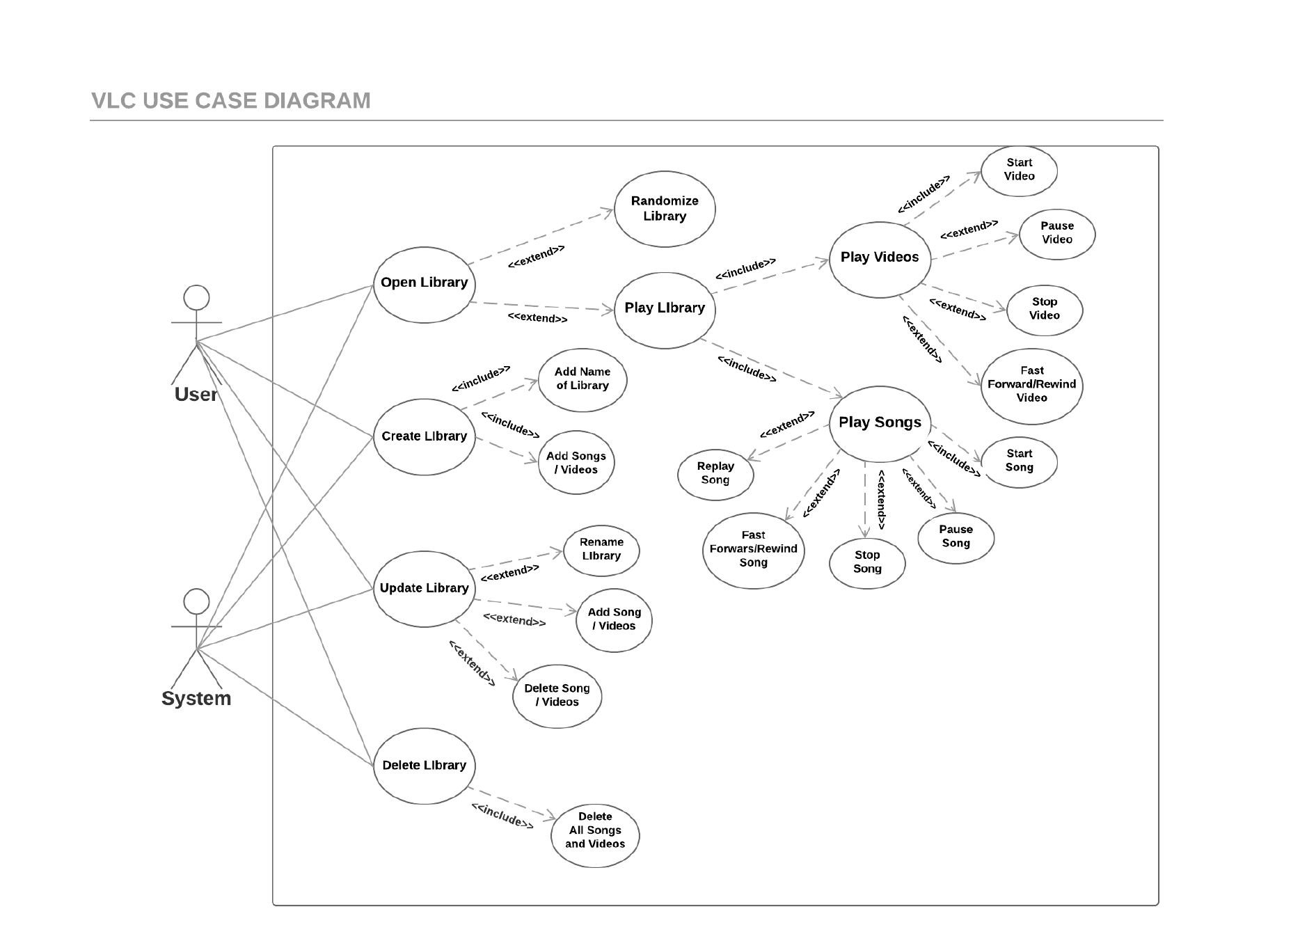**Use Case diagram**

**References:**

**“DON’T FORGET APA REFERENCING”**

**“JUST SET THE REFERENCES AS WEBSITE AND NO AUTHOR OR DATE CAUSE WEBSITE ANYWAY 😉”**

<https://www.videolan.org/vlc/download-android.html>

<https://play.google.com/store/apps/details?id=org.videolan.vlc&hl=en>

**References for photo:**

**“Insert the citation under the photo”**

**VIDEO LIBRARY**

<https://images.videolan.org/vlc/screenshots/android/library-video-landscape-medium.jpg>

**AUDIO LIBRARY**

https://lh3.googleusercontent.com/PES21T6lSyGV3qG-xUGXQjPnrZssxIkquURtY1s8occr6jnoK9RbhKqduDCS-NAHLUg=w720-h310